Software Requirements Specification
for
Workshop Machines
Version 1.0
Prepared by Juan David Amezquita Nuñez
Universidad Santo Tomás Seccional Tunja
March , 2023
Table of Contents
Table of Contents ii
Revision History ii
1. Introduction 1
1.1 Purpose 1
1.2 Document Conventions 1
1.3 Intended Audience and Reading Suggestions 1
1.4 Product Scope 1
1.5 References 1
2. Overall Description 2
2.1 Product Perspective 2
2.2 Product Functions 2
2.3 User Classes and Characteristics 2
2.4 Operating Environment 2
2.5 Design and Implementation Constraints 2
2.6 User Documentation 2
2.7 Assumptions and Dependencies 3
3. External Interface Requirements 3
3.1 User Interfaces 3
3.2 Hardware Interfaces 3
3.3 Software Interfaces 3
3.4 Communications Interfaces 3
4. System Features 4
4.1 System Feature 1 4
4.2 System Feature 2 (and so on) 4
5. Other Nonfunctional Requirements 4
5.1 Performance Requirements 4
5.2 Safety Requirements 5
5.3 Security Requirements 5
5.4 Software Quality Attributes 5
5.5 Business Rules 5
6. Other Requirements 5
Appendix A: Glossary 5
Appendix B: Analysis Models 5
Appendix C: To Be Determined List 6

Revision History
Name | Date | Reason For Changes | Version

Introduction

Purpose
Workshop of two machines and 5 works

System Features
In a workshop, there are two machines, which we will call A1 and A2. At the beginning of the day, five jobs need to be carried out: W1, W2, W3, W4, and W5.

The following table shows how long we need to work on the machines in minutes:
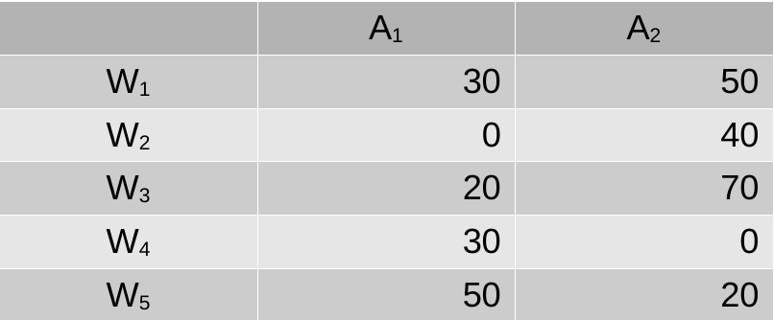

A zero indicates that a job does not require that machine. Jobs that require two machines must pass through A1 and then through A2. Suppose that we decide to carry out the jobs by assigning
them to each machine so that when they become available, the first executable job is started first, in the order from 1 to 5. If, at the same time, more jobs can be executed on the same machine, we will execute the one with a minor index first.

The purpose of modeling is to determine the minimum time needed to complete all the works.

4.1 Functional Requirements

Requirement | FR-01
Name | Number of machines
Conditions | A machine must have a name and status. The status determine if a machine is busy or idle.
Priority | High

Requirement | FR-02
Name | Number of works
Conditions | A work can executed with one or two machines. The execution time is expressed in minutes. The work must be executed in the machine 1 first, only if it has execution time. The work status determines if the work is in progress. The work has tasks, each task corresponds to one machine.
Priority | High

Requirement | FR-03
Name | Tasks
Conditions | Define the minutes of the work per each machine. The tasks also have a status of the execution.
Priority | High

Requirement | FR-05
Name | It is a simulation model.
Conditions | The simulator has a clock, parameters, statistical module, and so on.
Priority | High

4.2 Other Nonfunctional Requirements

Requirement | NFR-01
Name | The simulator interface can be CLI (Console Line Interface).
Conditions | It is necessary show the simulator progress and the statistical results.
Priority | Low

<Collect a numbered list of the TBD (to be determined) references that remain in the SRS so they can be tracked to closure.>

